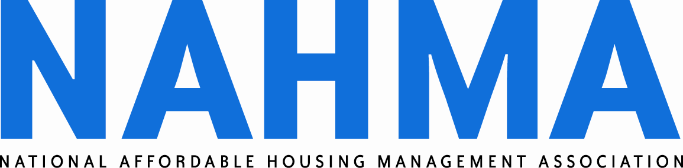
400 North Columbus Street, Suite 203
Alexandria, VA 22314
(703) 683-8630
(703) 683-8634 FAX
www.nahma.org
January 31, 2006

Mr. Eric Solomon
Acting Deputy Assistant Secretary for Tax Policy
Deputy Assistant Secretary for Regulatory Affairs
Office of Tax Policy
U.S. Department of the Treasury
1500 Pennsylvania Avenue N.W.
Washington, DC 20220

Dear Eric:

NAHMA sincerely appreciates the time you and your colleagues took to listen to our concerns on January 19. Our discussion covered many different aspects of the challenges management agents face in complying with Section 42 regulations. I would like to take this opportunity to follow-up on the key issues.

Energy costs

Our first point of discussion was the financial strain placed on Section 42 properties by soaring energy costs. Please recall that the utility allowance (UA) is part of the gross rent formula. Maximum tax credit rents can not exceed 30 percent of 60 percent of area median income. When the UA increases, the rent to the owner decreases.

NAHMA looks forward to publication of the proposed regulation for determining a more accurate utility allowance. This rule change was requested by a coalition of trade associations which represent owners and management agents involved with the Section 42 program. We agree that having a more accurate UA will often result in a lower UA for newer, energy efficient properties. We believe this change will improve the financial outlook for many struggling properties, and we look forward to the opportunity to submit comments.

We will request emergency assistance from Congress to help properties deal with the immediate skyrocketing energy costs. This assistance could come in the form of a special appropriation, a rent increase tied to an objective indicator—such as the price of oil, or other means. Ideally, our members would like Congress to consider removing the UA from the rent equation altogether.

Hurricane aftermath issues

Extending the temporary recapture relief period for major disaster areas would offer a great degree of financial stability to Section 42 properties damaged by Hurricanes Katrina, Rita and Wilma. NAHMA has sent a letter to Susan Reaman requesting that the IRS issue a new revenue procedure to extend the temporary recapture relief period. Our specific recommendation was to extend the relief to 48 months, with an option to lengthen it again if necessary.

We feel the extension is justified by circumstances that continue to challenge the Gulf Coast. For example, nearly five months after Katrina struck, whole neighborhoods in the New Orleans area remain without electricity. NAHMA has learned from local FEMA officials in Louisiana that new flood plains maps will not be available before May, or more likely August of this year. Many affordable housing operators are still clearing debris from their properties, waiting for insurance payments, and looking for sources to finance repair and rebuilding efforts.

As Treasury and the IRS prepare further guidance or regulations pertaining to relief and rebuilding efforts in the Gulf Coast, please feel free to use NAHMA as a resource for information you may require.

"Good cause" eviction protection pursuant to Revenue Ruling 2004-82

Please recall that our strongest objection on this subject was the IRS’ interpretation that the good cause protection is applicable to termination of tenancy throughout the entire affordable use period for the property. NAHMA’s position remains that entering into a lease agreement is a matter of contract which both parties should willingly enter. We believe this provision encroaches on an owner's right to enter into the contract freely.

In the practice of property management, an owner’s decision not to renew a lease is considered a type of “termination of tenancy.” It is unclear whether the IRS specifically intended “termination of tenancy” to include non-renewal of leases upon expiration, but states and local courts will certainly interpret the language this way.

Our concerns about the practically of this revenue ruling could be addressed if the IRS would issue further clarification to state agencies, preferably through a new revenue ruling, specifying that failure to renew a lease with the tenant upon expiration of the lease does not constitute “termination of tenancy” pursuant to Q&A-5 of Rev. Rul. 2004-82 and the subsequent Rev. Proc 2005-37, which provides a safe harbor for meeting the requirements described in Q&A-5 of Rev. Rul. 2004-82. An official policy statement which clarifies that owners retain the right not to renew expiring leases without having to show good cause would satisfy the majority of our concerns and allow our members to continue operating communities of quality.

Household changes that put the household over-income

We understand that a prospective requirement is being considered for inclusion in the 8823 guide to state agencies which would require households to move out if a change in the composition of that household puts them over-income. We continue to believe that any requirement to move-out families that become over-income due to a change in the household income would be potentially discriminatory based on familial status, inadvisable, and probably not very enforceable in local landlord-tenant courts.

NAHMA strongly recommends removing any such language from the 8823 guide prior to publication. We suggest providing states with an explanation about why this section was removed, instructing them that the Code only speaks to the next available unit rule when a household becomes over-income and is silent on how to address the changes in the household. Likewise, we strongly urge the Agency to defer to the HUD 4350.3 occupancy handbook for questions on which the Internal Revenue Code is silent. An explicit deferral to the 4350.3 would provide consistency throughout the industry, an immediate resource for answers when occupancy questions arise and a way to minimize conflicts between program requirements for mixed subsidy properties.

Student occupancy in Section 42 housing

NAHMA will seek a statutory change permitting otherwise qualified tenants to pursue an education without fear of losing their housing. We firmly believe that affordable housing should be a stepping stone to self-sufficiency. In many cases, it is further education that enables this transition. Our efforts would be greatly assisted if the Administration formally requested this change from Congress.

Conclusion

NAHMA members represent the front-line providers of Section 42 housing. Our members are responsible for implementing the rules and regulations which govern this vital program. I look forward to building a stronger partnership with you and your colleagues to ensure Section 42 remains a successful program. I strongly believe that open communication between the Administration and affordable housing operators is a key to ensuring the long-term viability of Section 42 housing.

Sincerely,

Kris Cook, CAE
Executive Director

Cc: Susan Reaman
Paul Handleman
Sharon Kay

