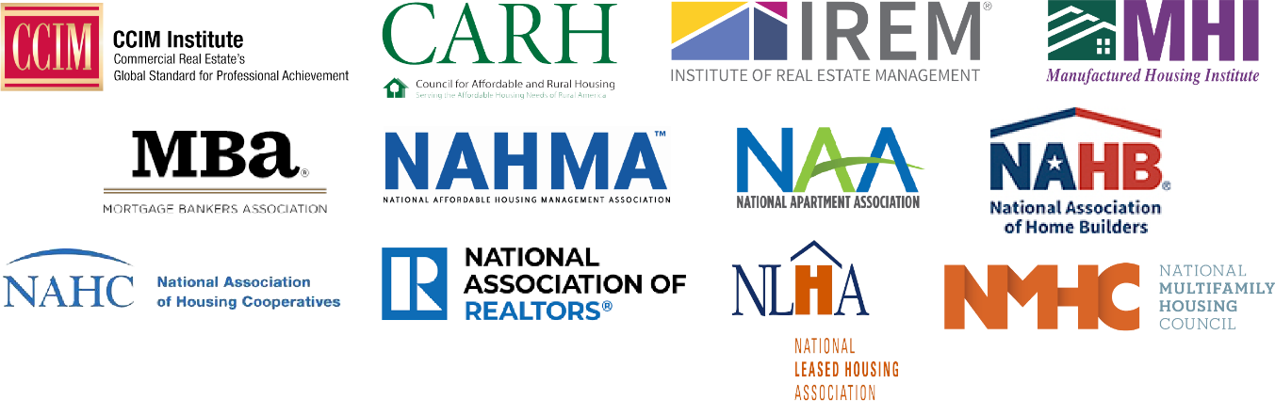
For Immediate Release:
January 25, 2023
[Your Press Contact]
[Phone Number]
[Email]

Real Estate Coalition Statement in Response to White House Announcement on Protecting Renters and Promoting Rental Affordability
Washington, D.C. – Our organizations agree that the U.S. faces a serious housing affordability crisis. And while the Administration has correctly made addressing this crisis a priority, we are disappointed that today’s release is solely focused on renter protections, creating potentially duplicative and onerous federal regulations that interfere with state and local laws meant to govern the housing provider and resident relationship. Unfortunately, this effort does nothing to address the underlying cause of the housing affordability crisis.
The U.S. needs to build more housing, of all types and at all price points. We urge the Administration to prioritize the Housing Supply Action plan it issued last year. We agree with President Biden’s own words when he released that plan: “The best thing we can do to ease the burden of housing costs is to boost the supply of quality housing.”
The competitive and professionally managed apartment industry is, by definition, resident-centered. There is no rental housing industry without our residents. We reiterate the message we conveyed in both meetings with and letters sent to the Administration in July and December of last year—removing obstacles to new housing production should be the Administration’s priority.

The coalition members include:

CCIM Institute
Council for Affordable and Rural Housing
Institute of Real Estate Management
Manufactured Housing Institute
Mortgage Bankers Association
National Affordable Housing Management Association

National Apartment Association
National Association of Home Builders
National Association of Housing Cooperatives
National Association of REALTORS®
National Leased Housing Association
National Multifamily Housing Council

