

|  |  |
| --- | --- |
| cert_03  Fair Housing Compliance™ (FHC™) | Instructions to Non-Proctored Exam  CPO FHC ACPO  “Go to test website to access exam”  [**https://app.testrac.com/nahma-1/delivery**](https://app.testrac.com/nahma-1/delivery) |

If you have already taken the NAHMA CPO, FHC, or ACPO online exams you can “**Sign In**” using your ID and password. *Please, note, the SHCM exam is hosted through a different application and requires a unique registration separate from this site*. If this is your first NAHMA online exam, you will need type in your contact information into the online exam enrollment portal. Be sure to have the voucher number that you received from the sponsored AHMA. You have 3 weeks to use the voucher and take the exam.

Use one of the following devices.

a) Desktop computer

b) Laptop computer

c) IPad tablet.

The internet browser used **MUST** be Chrome, Internet Explorer, or Firefox to ensure connectivity. We have verified that these devices and browsers are 100% compatible with the testing site.

In addition, we strongly suggest that the student clear out the cache, and make any updates to their device prior to the beginning of the exam to prevent any delays, or interruptions with the testing site.

The exam is timed. The following times are allotted. (Student should select the specific exam).

ACPO Exam – 2 hours

CPO Exam – 4 hours

FHC Exam – 2 hours

I. ACPO, CPO and FHC exams are “open book” – course manuals may be used as references during the exam. Calculators are allowed on all of the exams.

II. Your exam will be graded immediately upon completion of the exam. You will be the first to learn of your results. You will receive an official letter from NAHMA 14 business days after your test date.

III. You will be able to keep track of how much time is left to complete the exam- the clock will be in the corner of your screen. Follow the instructions to access the exam on the next page ------Let’s begin!

**For new students click register as shown below on test site.**

**If you have already taken the NAHMA CPO FHC ACPO online exam you can**

**“Sign In” using your ID and password.**

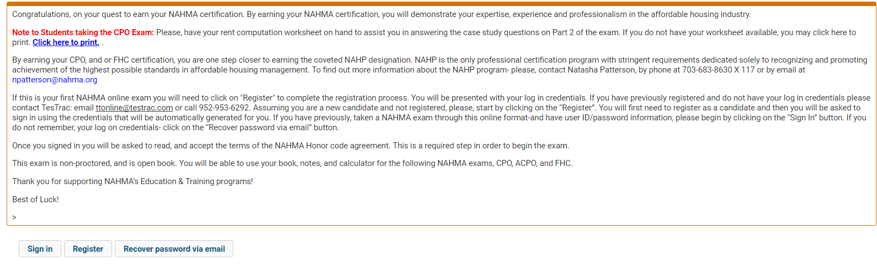

**Complete the Personal Profile Information**

**& enter all details then click create account.**

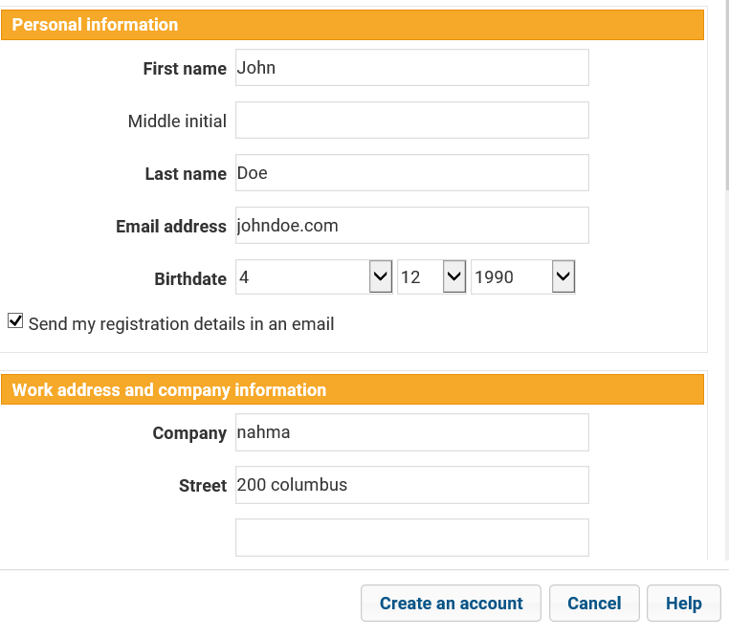

**You will receive a prompt with your log in credentials… Click ok. Sign in.**

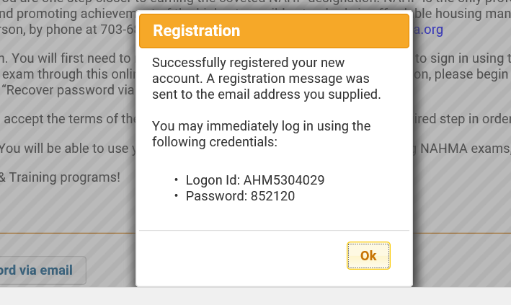

**Enter your log-on ID and password**

**Accept the terms and conditions then click sign in.**

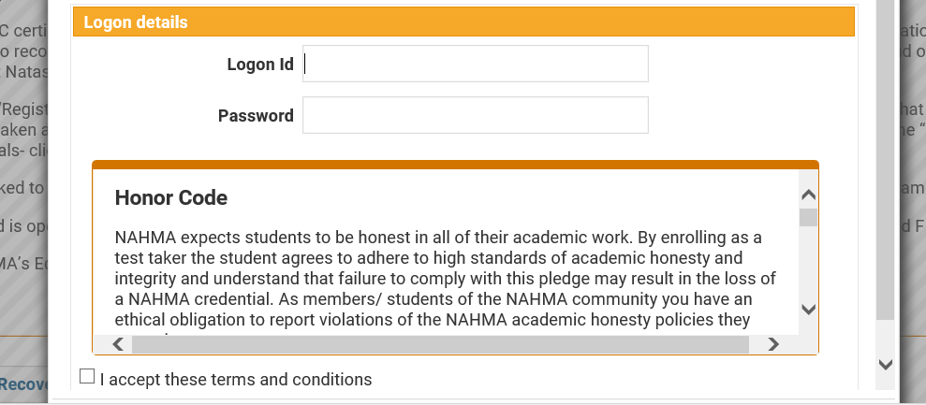

**Click Publicly available and choose the exam from the drop down list.**

**If you select the wrong exam you will not receive a new voucher from your local AHMA, NAHMA or TESTRAC**

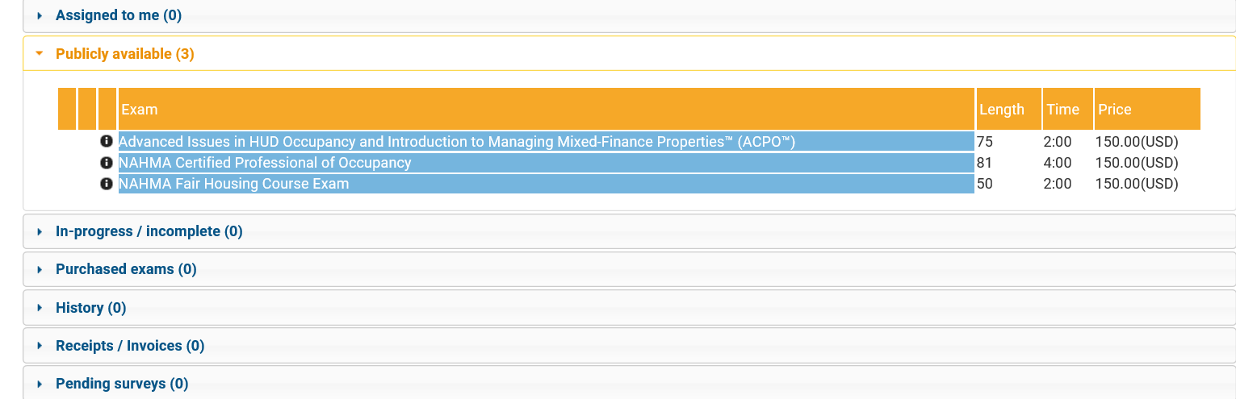

**Confirm the exam selected**

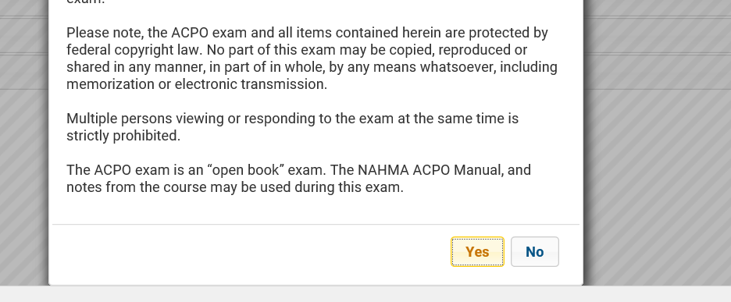

**Choose “voucher only” and enter voucher number in payment details.**

**Once you enter your voucher number click “purchase” below and follow the next steps to start your exam.**

**If you pay with your credit card you will not be reimbursed by your local AHMA, NAHMA, or TESTRAC**

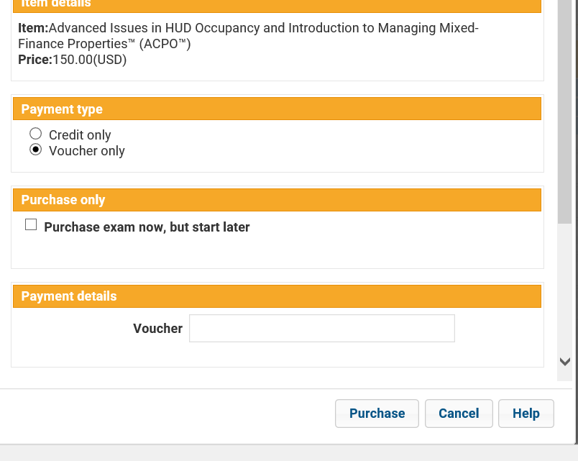

Connd

**For problems accessing the exam contact:**

TesTrac.com, Ltd.

Douglas B. Odell

Owner

1409 Summit Oaks Drive

Burnsville, MN. 55337

952-997-0641

Fax 952-432-6646

[dbodell@testrac.com](mailto:dbodell@testrac.com)

[www.testrac.com](http://www.testrac.com/)

**Questions regarding certification & testing contact:**

Natasha Patterson

Training & Education Coordinator

National Affordable Management Housing Association

400 N. Columbus Street, Suite 203

Alexandria, VA 22314

703-683-8630 ext 117

[npatterson@nahma.org](mailto:npatterson@nahma.org)

[www.nahma.org](http://www.nahma.org)