
NAHMA is the leading voice for affordable housing management, advocating on behalf of multifamily property owners and managers whose mission is to provide quality affordable housing. It supports legislative and regulatory policy that promotes the development and preservation of decent and safe affordable housing, is a vital resource for technical education and information, fosters strategic relations between government and industry and recognizes those who exemplify the best in affordable housing. Founded in 1990, NAHMA’s membership today includes some of the industry’s most distinguished multifamily owners and management companies.

The NAHP® CERTIFICATION

The National Affordable Housing Professional (NAHP®) credential was developed by NAHMA to recognize those individuals who own, operate, manage, or assist in the management of affordable housing, and who, by completing strict NAHP® requirements, have met the highest possible industry standards. NAHP® certification is available at the following levels:

Professional: Successful candidates have a minimum of two years of industry experience, and must also meet an education component comprised of occupancy (NAHMA’s CPO or SHCM), Fair Housing (NAHMA’s FHC), and basic apartment management skills.

Executive: This select level of certification was designed to recognize our industry's most qualified executives. NAHP®-e candidates must accumulate a minimum of five years of experience in the affordable housing industry. At least three (of the five) years of experience must be at an executive level, functioning as an active owner, CEO, managing agent, asset manager, district/regional manager or equivalent.
CERTIFIED PROFESSIONAL
OF OCCUPANCY

The Certified Professional of Occupancy (CPO) course is a comprehensive program offered by the National Affordable Housing Management Association (NAHMA) for property management staff in affordable developments, including LIHTC. It is the only occupancy course that covers the HUD 4350.3 Handbook in its entirety, with specific handbook references cited in the margins of the course text.

Each participant will receive a copy of the 4350.3 Handbook at this course. The two and a half day program is composed of occupancy focused instruction. Participants will receive a voucher from their hosting AHMA to take the CPO exam independently on their own at their home office, or property. Students that successfully pass the exam will receive a CPO certificate and lapel pin. All CPOs will be listed in an online national certification directory. The CPO is a requirement for NAHMA’s National Affordable Housing Professional (NAHP®) certification program.

Fees and reasonable expenses for the course are an approved project expense for front-line staff. It is recommended that course attendees have a basic knowledge of the HUD 4350.3 Handbook prior to registration.

It is recommended that attendees bring a highlighter, a calculator and Post It notes to the course.
A Comprehensive Course for Managers of Affordable Housing
INCLUDING LOW INCOME HOUSING TAX CREDIT DEVELOPMENTS
Certified Professional of Occupancy
COURSE SCHEDULE
DAY ONE
7:30 a.m. - 8:15 a.m. Registration
8:15 a.m. - 12 p.m. Morning Session
12 p.m. - 1:00 p.m. Lunch
1 p.m. - 5 p.m. Afternoon Session
5:15 p.m. Adjourn
5:30 p.m. - 6:30 p.m. Review Session (Optional)

DAY TWO
8 a.m. - 12 p.m. Morning Session
12 p.m. - 1:00 p.m. Lunch
12:45 p.m. - 5:15 p.m. Afternoon Session
5:15 p.m. Adjourn
5:30 p.m. - 6:30 p.m. Review Session (Optional)

DAY THREE
8 a.m. - 12 p.m. Morning Session

INSTRUCTOR BIO

Instructor
Title
Company
Bio Text goes here

AHMA BIO
Bio Text goes here

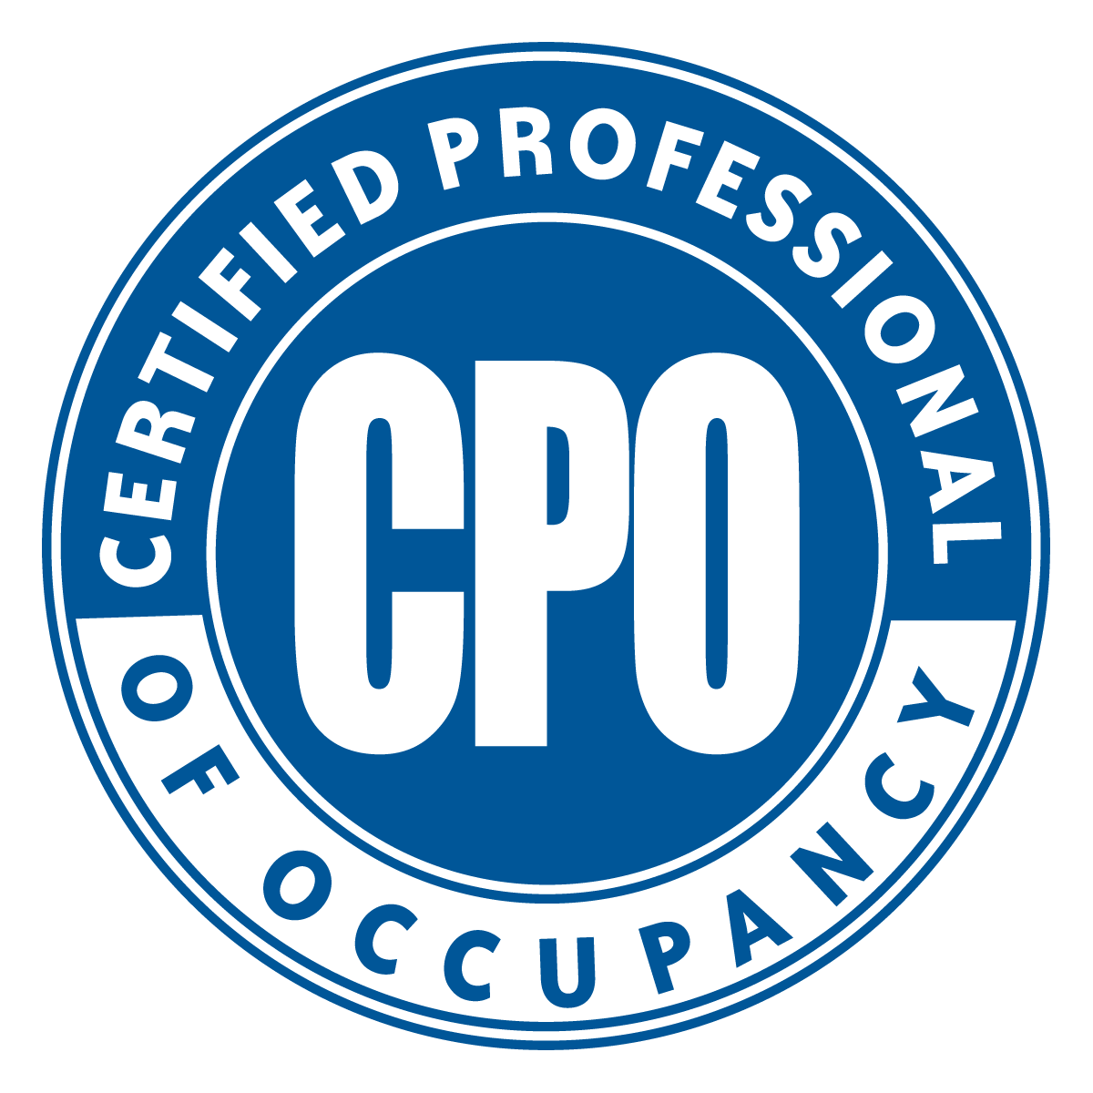

CERTIFIED PROFESSIONAL OF OCCUPANCY

The Certified Professional of Occupancy (CPO) course is a comprehensive program offered by the National Affordable Housing Management Association (NAHMA) for property management staff in affordable developments, including LIHTC. It is the only occupancy course that covers the HUD 4350.3 Handbook in its entirety, with specific handbook references cited in the margins of the course text.

Each participant will receive a copy of the 4350.3 Handbook at this course. The three-day program is composed of two and a half days of instruction and a half-day exam. Participants who successfully
pass the exam will receive a CPO certificate and lapel pin. All CPOs will be listed in an online national certification directory. The CPO is a requirement for NAHMA’s National Affordable Housing Professional (NAHP®) certification program.

Fees and reasonable expenses for the course are an approved project expense for front-line staff. It is recommended that course attendees have a basic knowledge of the HUD 4350.3 Handbook prior to registration.

Certified Professional of Occupancy


Please complete a separate form for each registrant, and mail with payment by _Date

Name:
Title:
Property Name:
Company:
Address:
Phone: Fax:
Number of years worked in affordable housing:

AHMA Members: $535
AHMA Members: $499
(Three or more from same company.)
Non-Member: $579
Total Amount Enclosed:

Make Checks Payable To:

AHMA
AHMA Address
AHMA City, St. ZIP
AHMA phone: fax:

There is a $50 administrative fee for cancellation 15 working days prior to the course. After this date, fees are nonrefundable. A substitute may be sent in the place of the registrant. Class space is limited, therefore your registration must be accompanied by full payment in order to confirm your space for this CPO course.

This organization complies with Title III of the Americans With Disabilities Act (ADA). The site is accessible for individuals with disabilities and if a registrant requires special accommodations, please contact the AHMA office at least ten days prior to the date of the course.

REGISTRATION FORM
COURSE LOCATION

Course Site
Address
City, St. Zip
Phone

Course space is extremely limited.
Registration is on a first come, first served basis.
DIRECTIONS

Directions

